Trial of Digital Modes Using the Club Remote IC-7100 Station.
Set Up Guide and Early Trial Results.

Alex Stewart VK2PSF & Edwin Lowe VK2VEL (07AUG16)

Abstract
This protocol for digital modes using the club remote station was developed by Alex VK2PSF. It uses Digital Master 780 (DM780) from the Ham Radio Deluxe (HRD) suite as the digital mode software to operate AFSK digital modes and for the CAT control/PTT of the remote Icom IC-7100 via the RCForb client. Additional JT65 mode operation is possible through JT65-HF software. This protocol replicates the digital station set up of radio to PC soundcard interface and PC CAT/PTT control of the radio. Unlike a setup in the shack, this protocol uses virtual audio cables to interface between the IC-7100/RCForb and DM780 (and JT65-HF). The minimum setup cost is US$1.00 for donationware virtual audio cables. All other software is freeware. This protocol has so far, demonstrated reliable transmit and decode on RTTY (AFSK), PSK31 and JT65 modes.

Club Hardware Used
The club remote station operates the Icom IC-7100 at Rose Bay. It is currently connected to an 80m OCF dipole (160m-6m) and a 2m/70cm vertical.

Member Software Requirement
- The remote IC7100 control system uses RCForb client. Go to the club website for set up and access instructions.
http://www.vk2bv.org/remote-station/
The system is easily set up for phone modes.

For digital modes, you need additional software

- ‘VB-cable’ is a virtual audio cable. These act as the virtual audio interface cables in place of the cables between the PC and radio in the shack.
http://vb-audio.pagesperso-orange.fr/Cable/index.htm
You can download x1 free virtual audio cable, but you will need x2 virtual audio cables (one for receive and one for transmit). Download and install the x2 virtual audio cables, which they call ‘VB-Cable-A’ and ‘VB-Cable-B’. This is donationware and US$1.00 via their Paypal link will work. Of course, feel free to donate more if you wish.

- Digital Master 780 (a part of Ham Radio Deluxe suite) is the digital mode engine for a wide range of digital modes, and will interface with the RCForb client for transmit and receive control of the radio. The final free version of Ham Radio Deluxe is v.5.24.38. Download and install. http://www.iw5edi.com/software/ham-radio-deluxe-5-download-links

- JT65-HF will allow JT65 mode operation. Download and install.
http://jt65-hf.com/downloads/

Note: This guide only describes the basic set up of the software and a brief review of operating. If you are new to digital modes, please familiarise yourself with the mode(s) of interest and the software before you begin.

Setup

Download and install all the software.

Configure the audio devices for the VB-Cables.
1. Set the Windows Recording & Playback settings to the VB-Cables.
- Set Windows Playback to ‘Cable-A Input’ and Recording to ‘Cable-B Output’
- Set both as ‘default devices’. (don’t forget to change them back once you have finished using the system)

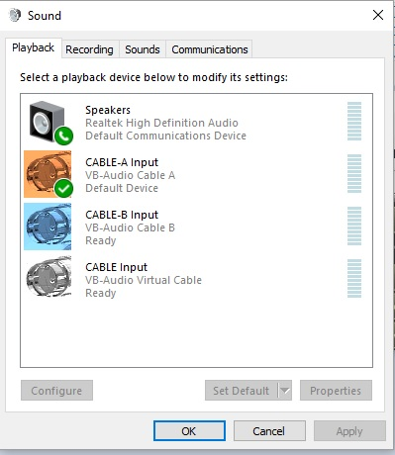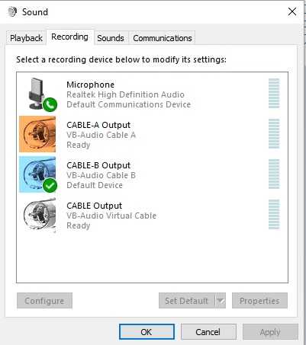

2. RCForb
1. Set SPKR to Cable-B Input and MIC to Cable-A Input
(Digital modes will be ‘silent operation’, spotting signals on the DM780 waterfall, although you can toggle SPKR and MIC to the standard Windows speaker and mic devices to either listen/search for digital signals or to operate phone modes.)

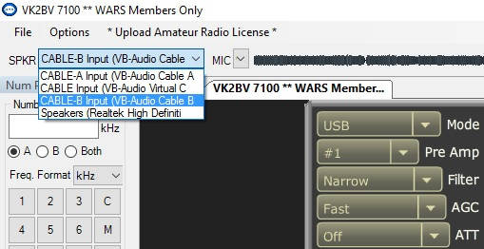

3. DM780
1 Set your DM780 soundcard Input (Receive) to Cable-B and Output (Transmit) to Cable-A.

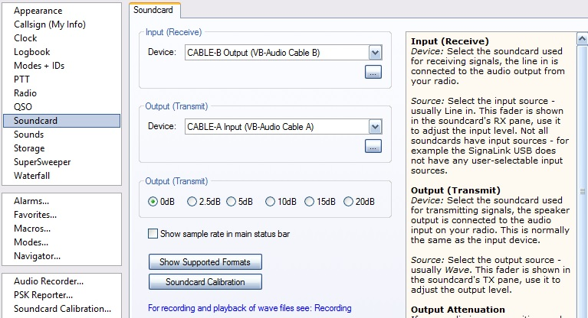

4. JT65-HF
1 Set your JT65-HF soundcard input to Cable-B and Output to Cable-A
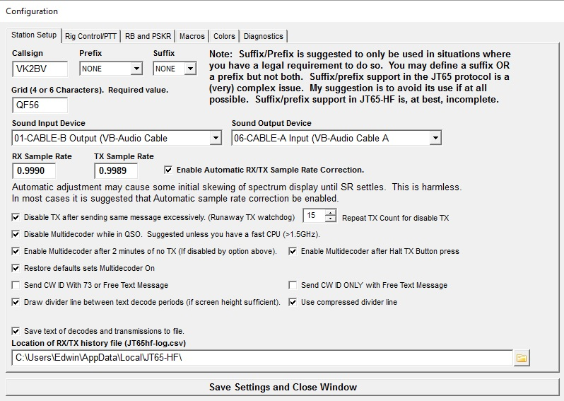

Configure the CAT/PTT controls

1. RCForb
1. Set the HRD Server Emulation in RCForb ‘Options’ as below.

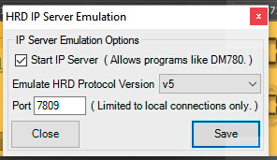

2. JT65-HF
1. Set the JT65-HF ‘Rig Control/PTT’. Enable Ham Radio Deluxe Version 5 and check the HRD Server address is set as below.
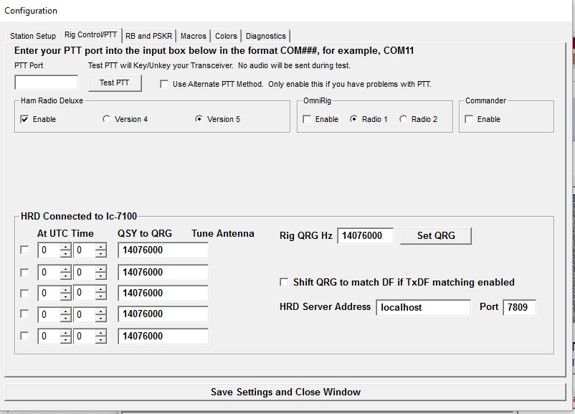

2. DM780
Start DM780 as a stand alone programme only. (Do not start the entire Ham Radio Deluxe suite, which will ask you to configure the radio connection. – You will configure CAT and PTT control directly through DM780. You can open the HRD Logbook programme directly through DM780.)

- Open ‘Program Options’ and then ‘PTT’.
- Select PTT via Ham Radio Deluxe.

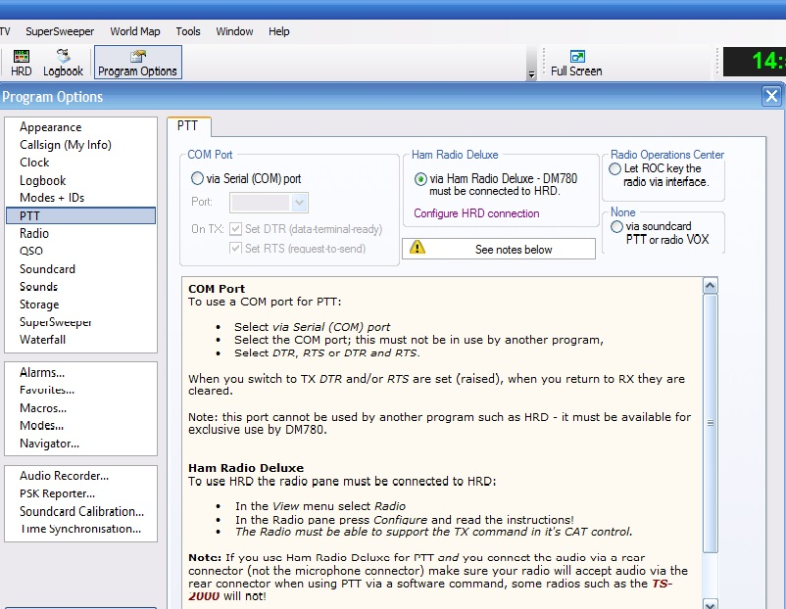

- Open ‘Configure HRD Connection’
- Configure the HRD User Interface Address and Port as shown below
- Add the ‘TXd’ button from the drop down list options
- Save the configuration
- When all the configuration steps have been set up, press ‘Connect’ in DM780

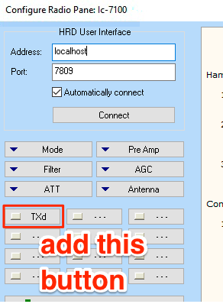
Successful Configuration

Ensure that the following programmes are running.
- RCForb connected to the club IC-7100
- DM780 connected to the IC-7100/RCForb system
- HRD Logbook opened via DM780
- JT65-HF opened and connected to DM780

If you have configured the audio and software setups correctly, your DM780 display should show the radio connection on the left, HRD log entry in the centre (display configurations may differ) and the rx and tx windows on the right. Note the PTT and Input/Output configurations listed in the rx window. The waterfall should show reception of noise and signals (and not a black blank screen).
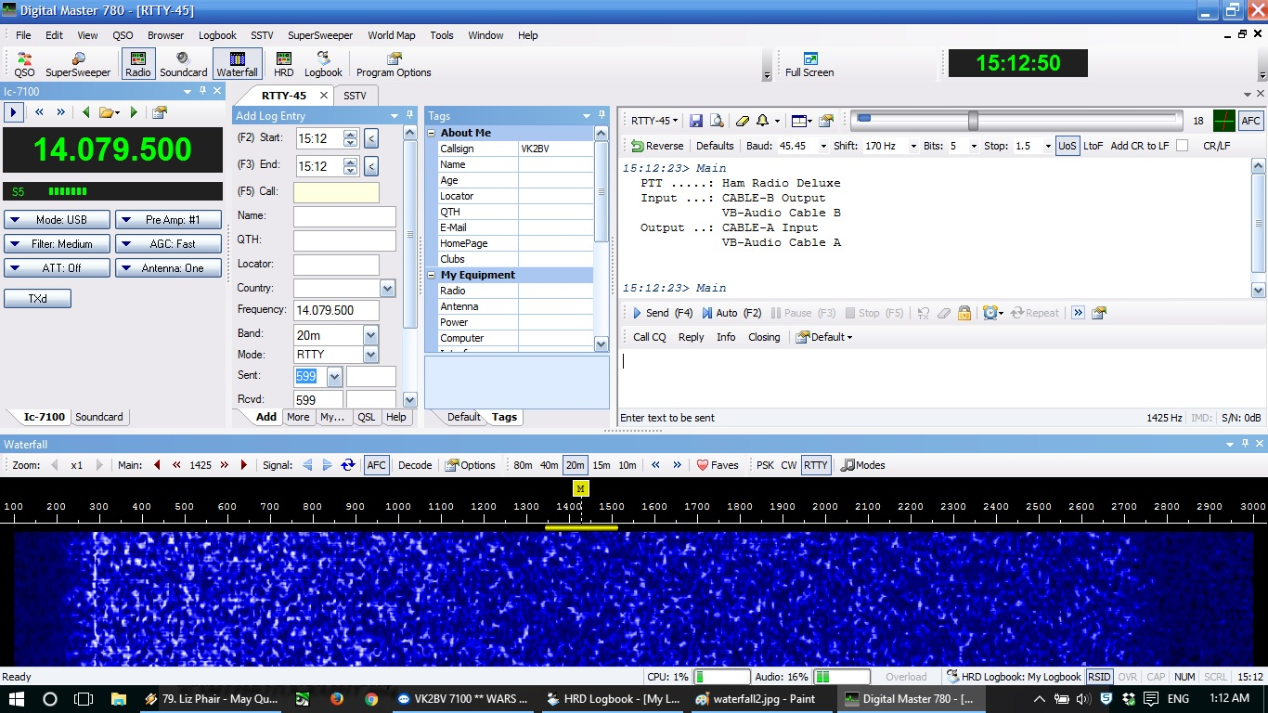

Similarly, the JT65-HF waterfall will show reception of noise or signals (and not a blank screen), if the audio is correctly configured. The radio’s frequency should appear under ‘Dial QRG kHz’ (left).

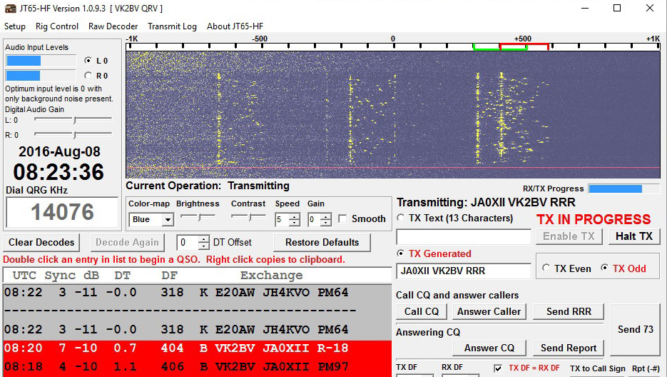
Configure Audio and Transmit Power Settings.

Ensure that the radio (in RCForb) is set for:
‘Compression’ (speech processor) OFF
Transmit power 100%
USB mode (all AFSK digital modes operate in USB regardless of band)

As normal in AFSK modes, control your transmit power through your audio levels, not the tx power setting. Remember that these digi-modes are 100% duty cycle. Do not transmit any higher than 50% power ie 50w indicated on the meter.

You should aim to configure your audio levels so that the meter indicates a maximum of 40w transmit power, allowing for fluctuations up to 50w (more in the next section). In RTTY mode (and to a lesser extent PSK31), my trials have shown that consistent transmit power can be set with the following settings. JT65 is an exception. See further in ‘Results’

- Radio Mic Gain level 30%
- RCForb MIC input level can be about 30%
- Windows Audio Playback level can be about ‘5-10%’ and Recording levels can be set mid-level ‘50%’.
- RCForb Volume level seems to have the greatest effect on receive input levels. Aim to set the RX input level displayed on the left of the DM780 soundcard screen at 10% to start with.

The DM780 TX level control (below, left) seems to have the greatest effect on the transmit power. I am finding that a setting of about 18-20%% (in conjunction with the settings above) produces about 35-40w tx power in RTTY and PSK.
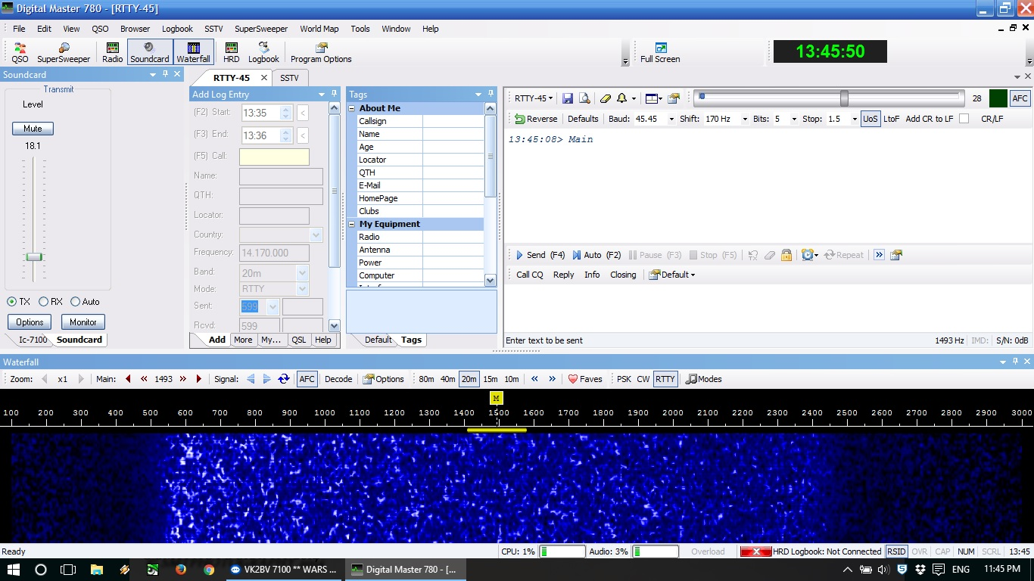

These levels are simply from my own trials and as usual, your experience and system may vary. The most important objective is to keep your transmit power reasonably constant between 30w-40w and always below maximum 50w transmit power.

Unlike a radio in your shack, there is no dummy load to adjust levels and power. It is best to experiment and set up your levels on a ‘dead band’ eg 10m band at night, 80m in the day etc.
Results with Modes

Generally, signal quality in receive and transmit is in a large part, determined by the quality of the audio through the internet, in addition to propagation, QRM, QRN etc on the RF side.

One particular challenge in my trials is maintaining a consistent transmit power within the desired range (ie under 50w).

My trials have used RTTY, PSK31 and JT65.

RTTY gave the most consistent results with a consistent tx power. With an objective of 40w tx power, I find that tx power will vary from 30w-45w. I have successfully worked myself, using the remote and my own shack at 35km distance on 80m. Further ‘real’ on air testing is required.

PSK31 transmit power tends to fluctuate a moderate amount. With an objective of 40w tx, I find that tx power can fluctuate from between 20w-45w, but can occasionally spike to up to 80w. I have tried to vary the various audio settings on the transmit side (ie Radio Mic Gain, Windows Playback/speaker level, DM780 tx level, RCForb MIC level) but have yet to eliminate the fluctuation. It seems reliable in decode and transmit with VK stations in tests so far.

JT65 was tested using JT65-HF software. Receive and decode was the most reliable even with DX signals due to the nature of data redundancy in this mode. However transmit requires special care. Audio levels were very sensitive and critical to controlling tx power at useable levels.
- RCForb MIC level must be set at a bare minimum, just above 0
- Windows Playback level should be kept minimum eg 1-5
- Radio Mic gain should be minimum eg 5%
- RCForb TX Power should be set low eg under 30% for 30w tx power. AFSK mode tx power is usually controlled by audio levels, but this is an exception. It is essential that JT65 should never be operated above 30w tx power on the radio power meter. This is a 100% duty cycle for a 50 second tx period, and any more than 30w increases the likelihood of damaging the radio.

I found that even the smallest increase in RCForb Mic level will result in overdriving the tx output, resulting in large fluctuations in tx power, sometimes spiking to 80-100%.

Additionally, a manual PTT of the TXd button on RCForb was required to begin and end the transmit cycle. Unfortunately, while JT65-HF will read the frequency in DM780, it does not have a PTT control interface, so it must be a manual PTT.

While this is a sensitive set up and fiddly operating method, the results on JT65 are well worth the effort, since the signal data redundancy of the mode makes it a very robust mode for remote operating due to the variations in audio quality through the internet. DX was worked very easily.

See screenshot below:

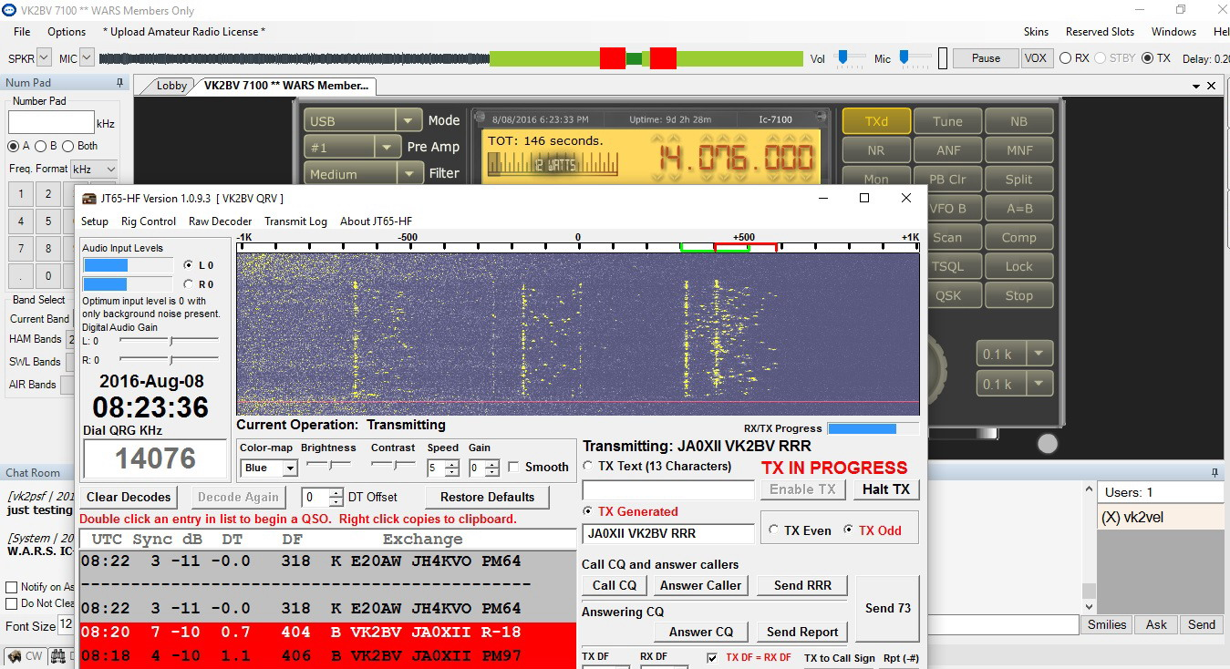
RCForb TX waveform
↓

Note:
- ‘TXd’ PTT button on RCForb that must be manually pushed to start and stop the tx cycle
- The tx ‘waveform’ in RCForb. Note the acceptable green tx levels and the unacceptable, overdriven red levels. The tx power of green was no more than 30w. The smallest increase in RCForb MIC levels resulted in overdriven signal, driving the tx power to 80w-100w

CW was attempted, but I could not set it up to transmit keyboard CW (not AFSK MCW) through DM780/RCForb, a result which replicates my experiences with DM780 in my own shack PC/radio (my own shack DM780 will only function on keyboard CW through a Winkeyer interface).

Summary
The club remote IC-7100 is controlled using the RCForb client and the Ham Radio Deluxe DM780 software presents a useful digital mode engine, due to its ability to PTT and CAT control interface with RCForb, its integrated HRD Logbook, and the continuing availability of the discontinued HRD v.5.24.38 freeware. The only cost in this set up is the VB-Cable virtual audio cables donationware, and a minimum donation of US$1.00 is sufficient. Early trials point to a potentially useful remote digital mode capability, determined in part by the quality of the audio through the internet. RTTY and PSK31 have been successful in early trials, though more extensive testing with real QSOs is required. JT65 whilst fiddly to set up and slightly more complicated in operation with the JT65-HF software, is well suited for remote operation and proved itself immediately with DX. Further user trials are recommended and individual users will find their own optimum settings.

